Introduction

1.1Cyber Cafe

A Cyber cafe also known as an Internet Cafe, is a place which provides Internet access to the public, usually for a fee. These businesses usually provide snacks and drinks, hence the cafe in the name. The fee for using a computer is usually charged as a time-based rate.
Cyber cafes are located worldwide, and many people use them when traveling to access webmail and instant messaging services to keep in touch with family and friends. Apart from travelers, in many developing countries Internet cafés are the primary form of Internet access for citizens as a shared-access model is more affordable than personal ownership of equipment and/or software. A variation on the Internet café business model is the LAN gaming center, used for multiplayer gaming. These cafés have several computer stations connected to a LAN. The connected computers are custom-assembled for gameplay, supporting popular multiplayer games. This is reducing the need for video arcades and arcade games, many of which are being closed down or merged into Internet cafés. The use of Internet cafés for multiplayer gaming is particularly popular in certain areas of Asia like India, China, Taiwan, Hong Kong, South Korea and the Philippines. In some countries, since practically all LAN gaming centers also offer Internet access, the terms net cafe and LAN gaming center have become interchangeable. Again, this shared-access model is more affordable than personal ownership of equipment and/or software, especially since games often require high end and expensive PCs .
There are also Internet kiosks, Internet access points in public places like public libraries, airport halls, sometimes just for brief use while standing.
Many hotels, resorts, and cruise ships offer Internet access for the convenience of their guests; this can take various forms, such as in-room wireless access, or a web browser that uses the in-room television set for its display (usually in this case the hotel provides a wireless keyboard on the assumption that the guest will use it from the bed), or computer(s) that guests can use, either in the lobby or in a business center. As with telephone service, in the US most mid-price hotels offer Internet access from a computer in the lobby to registered guests without charging an additional fee, while fancier hotels are more likely to charge for the use of a computer in their "business center."
For those traveling by road in North America, many truck stops have Internet kiosks, for which a typical charge is around 20 cents per minute.
Cyber cafes come in a wide range of styles, reflecting their location, main clientele, and sometimes, the social agenda of the proprietors. In the early days they were important in projecting the image of the Internet as a 'cool' phenomenon.

System Requirements

3.1 Hardware Requirements
• Processor: Pentium IV or above
• RAM – 2 GB or more
• Hard Disk – 2GB or more

3.2 Software Requirements
Technologies used:
•Front End: NETBEANS IDE
•Back End: XAMPP Server
•RDBMS(Back end): MySQL
Software:
•PHP 5.39.5
•MYSQL Server
•Netbeans IDE and Microsoft Windows or Linux

System Design
3.1 ER Diagram
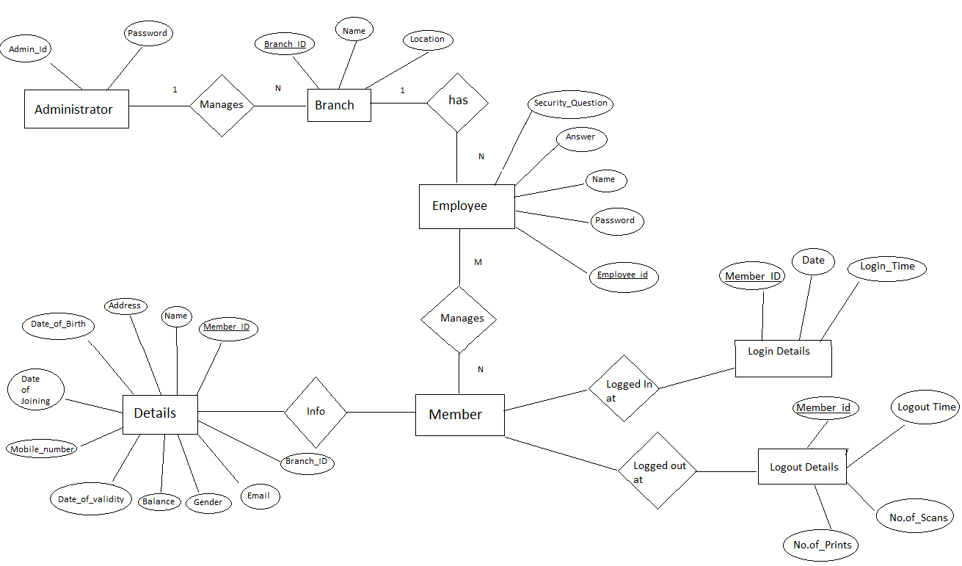
Fig 4.2 ER Diagram for Cyber Café

3.2 Schema Diagram

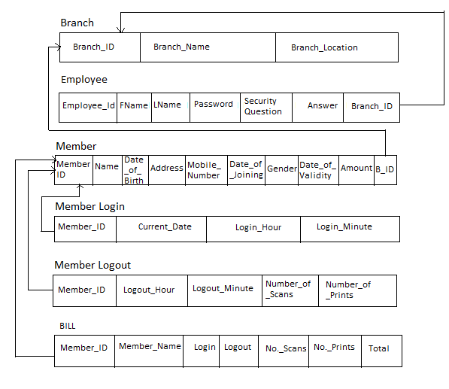
Fig 4.1 Schema Diagram

3.3 Normalization

- The table Member has one key attribute NAME to which the attribute PHNO and ADDRESS is dependent. As the PHNO can have multiple values, it is not in 1NF:
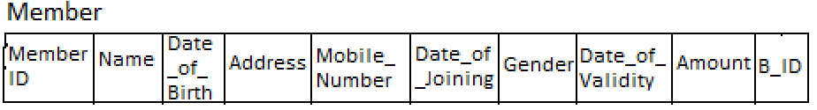
For example a Member can have 2 phnos with the same name, so we can normalize it into 1NF by using separate table form which is more efficient. It is already in 2NF because every non-prime attributes is fully dependent on primary attributes. It is also in 3NF because it is in 2NF and no non-prime attributes is transitively dependent on primary key.
- Branch Table is Normalized in 1NF,2NF as well as 3NF.

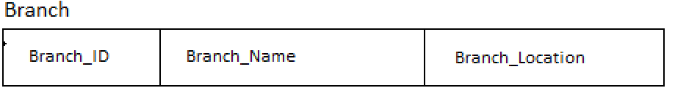

- Employee Table is Normalized in 1NF,2NF as well as 3NF.
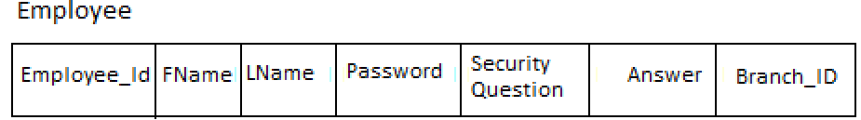

- Member Login Table is Normalized in 1NF,2NF as well as 3NF.
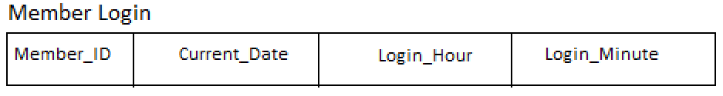

- Member Logout Table is Normalized in 1NF,2NF as well as 3NF.
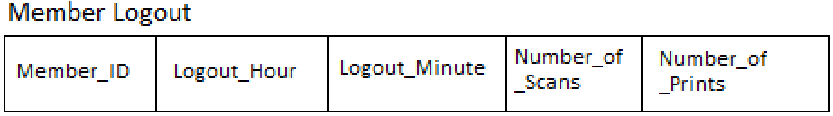

- Bill Table is Normalized in 1NF,2NF as well as 3NF.
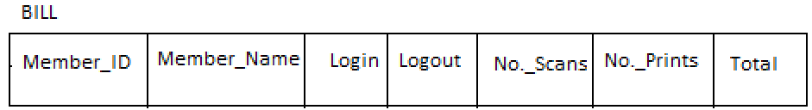

Chapter 4

Implementation

TECHNOLOGY OVERVIEW
The technology selected for implementing Cyber Cafe Management System is PHP/MYSQL.Apache is used as the HTTP server.The development was done in a ‘windows’ environment using adobe dreamweaver CS4.

JAVA Swing
Swing is a GUI widget toolkit for Java. It is part of Oracle's Java Foundation Classes (JFC) – an API for providing a graphical user interface(GUI) for Java programs.Swing was developed to provide a more sophisticated set of GUI components than the earlier Abstract Window Toolkit (AWT). Swing provides a native look and feel that emulates the look and feel of several platforms, and also supports a pluggable look and feel that allows applications to have a look and feel unrelated to the underlying platform. It has more powerful and flexible components than AWT. In addition to familiar components such as buttons, check boxes and labels, Swing provides several advanced components such as tabbed panel, scroll panes, trees, tables, and lists.

MySQL
MySQL is a relational database management system (RDBMS) ^{[1} ] that runs as a server providing multi-user access to a number of databases. MySQL is a popular choice of database for use in web applications and is an open source product. The process of setting up a MySQL database varies from host to host, however we will end up with a database name, a user name and a password. Before using our database, we must create a table. A table is a section of the database for storing related information. In a table we will set up the different fields which will be used in that table. Creating a table in phpMyAdmin is simple, we just type the name, select the number of fields and click the ‘go’ button. we will then be taken to a setup screen where you must create the fields for the database.Another way of creating databases and tables in phpMyAdmin is by executing simple SQL statements.We have used this method in order to create our database and tables.

XAMPP
XAMPP is a small and light Apache distribution containing the most common web development technologies in a single package. Its contents, small size, and portability make it the ideal tool for students developing and testing applications in PHP and MySQL. XAMPP is available as a free download in two specific packages: full and lite. While the full package download provides a wide array of development tools, XAMPP Lite contains the necessary technologies that meet the Ontario Skills Competition standards.The light version is a small package containing Apache HTTP Server, PHP, MySQL, phpMyAdmin, Openssl, and SQLite.

Obtaining and Installing XAMPP
All as previously mentioned, XAMPP is a free XAMPP packages and add-ons are package available for download and use
distributed through the Apache Friends website at the address: http://www.apachefriends.org/. Once on the website, navigate and find the Windows version of XAMPP and download the self-extracting ZIP archive. After downloading the archive, run and extract its contents into the root path of a hard disk or USB drive. For example, the extract path for a local Windows installation would simply be C:\. If extracted properly we will notice a new xampp directory in the root of your installation disk. In order to test that everything has been installed correctly, first start the Apache HTTP Server by navigating to the xampp directory and clicking on the apache_start.bat batch file.

4.2 Code Snippets

4.2.1 Config – To establish connection
This is a code snippet to show how Java is used to connect to the local MySQL database using the localhost server.
public class Jconnect {
public static Connection ConnectDB(){
try{
Class.forName("com.mysql.jdbc.Driver");
Connection conn = DriverManager.getConnection("jdbc:mysql://localhost/cybercafedb","root","");
System.out.println("Connected");
return conn;
}
catch(Exception e)
{

}

4.2.2 Config – Login Of Employee
String sql="Select * from employee where EID=? and Passwo=?";
try{
pst=conn.prepareStatement(sql);
pst.setString(1,jTextField1.getText());
pst.setString(2,jPasswordField1.getText());
rs=pst.executeQuery();
if(rs.next())
{
rs.close();
pst.close();

setVisible(false);
Home ob=new Home();
ob.setVisible(true);
}
else{
JOptionPane.showMessageDialog(null,"Incorrect Employee ID and Password");
}

4.2.3 Config – AdminLogin
//To Login in as Admin
String sql="Select * from administrator where AdminName=? and AdminPassword=?";
try{
pst=conn.prepareStatement(sql);
pst.setString(1,jTextField1.getText());
pst.setString(2,jPasswordField1.getText());
rs=pst.executeQuery();
if(rs.next())
{
rs.close();
pst.close();
setVisible(false);
AdminHome ob=new AdminHome();
ob.setVisible(true);
}
else{
JOptionPane.showMessageDialog(null,"Incorrect Admin Name and Password");
}

}
catch(Exception e)
{
JOptionPane.showMessageDialog(null,e);
}

4.2.4 Config – Employee SignUp
try{
String sql="Insert into employee(FName,LName,EID,Passwo,BranchID,SecQ,Answer)values(?,?,?,?,?,?,?)";
pst=conn.prepareStatement(sql);
pst.setString(1,jTextField1.getText());
pst.setString(2,jTextField5.getText());
pst.setString(3,jTextField2.getText());
pst.setString(4,jTextField3.getText());
pst.setString(5,jTextField5.getText());
pst.setString(5,(String)jComboBox1.getSelectedItem());
pst.setString(7,jTextField4.getText());
pst.execute();
JOptionPane.showMessageDialog(null,"New Account Created");

}

catch(Exception e)
{
JOptionPane.showMessageDialog(null,e);
}

4.2.5 Config – New Branch
//Using Stored Procedure For Adding Branch Details
CallableStatement cs;
try{
cs=conn.prepareCall("{ Call ADD_employee(?,?,?)}");
cs.setString("BI",jTextField1.getText());
cs.setString("BN",jTextField2.getText());
cs.setString("BL",jTextField3.getText());

cs.executeUpdate();
JOptionPane.showMessageDialog(null,"New Branch Added");
}
catch(Exception e)
{
JOptionPane.showMessageDialog(null,"Branchid Already Exists");
}

4.2.7 Config – New Member
try{
String sql="Insert into newmember(MID,MName,DOB,Address,Mno,DOJ,Gender,EmailID,Amount,DOV)values(?,?,?,?,?,?,?,?,?,?)";
pst=conn.prepareStatement(sql);
pst.setString(1,jTextField3.getText());
pst.setString(2,jTextField1.getText());
pst.setString(3,((JTextField)jDateChooser3.getDateEditor().getUiComponent()).getText());
pst.setString(4,jTextField5.getText());
pst.setString(5,jTextField5.getText());
pst.setString(5,((JTextField)jDateChooser2.getDateEditor().getUiComponent()).getText());
pst.setString(7,(String)jComboBox1.getSelectedItem());
pst.setString(8,jTextField2.getText());
pst.setString(9,jTextField4.getText());
pst.setString(10,((JTextField)jDateChooser1.getDateEditor().getUiComponent()).getText());
pst.execute();
JOptionPane.showMessageDialog(null,"New Member Added");
}
catch(Exception e)
{
JOptionPane.showMessageDialog(null,e);
}

4.2.8 Config – Login Member
currentDate();
String a1=jTextField2.getText();

String sql1="Select * from newmember where MID='"+a1+"'";
try{
String sql3="Delete From bill where MID='"+a1+"'";
pst3=conn.prepareStatement(sql3);
pst3.execute();

pst=conn.prepareStatement(sql1);
rs=pst.executeQuery();
if(rs.next()){
jTextField1.setText(rs.getString(2));
jTextField7.setText(rs.getString(10));
jTextField4.setText(rs.getString(9));

}
else{
JOptionPane.showMessageDialog(null,"Incorrect MemberID");
}

4.2.8 Config – Logout Member
a1=jTextField1.getText();
String sql1="Select * from newmember where MID='"+a1+"'";
try{

pst=conn.prepareStatement(sql1);
rs=pst.executeQuery();
if(rs.next()){
bal=Integer.parseInt(rs.getString(9));
Mid=rs.getString(1);
Mn=rs.getString(2);
jTextField2.setText(rs.getString(2));
String sql2="Select * from time where MID='"+a1+"'";
try{
pst1=conn.prepareStatement(sql2);
rs2=pst1.executeQuery();
if(rs2.next())
{
l3=Integer.parseInt(rs2.getString(3));
l4=Integer.parseInt(rs2.getString(4));
lin=rs2.getString(3)+":"+rs2.getString(4);
jTextField7.setText(rs2.getString(3)+" hr "+rs2.getString(4)+" min ");
a2=jTextField8.getText();
a3=jTextField11.getText();
a4=jTextField4.getText();
a4=jTextField3.getText();

}
rs2.close();
pst1.close();

}
catch(Exception e)
{
JOptionPane.showMessageDialog(null,e);
}
}
else{
JOptionPane.showMessageDialog(null,"Incorrect MemberID");
}

4.2.9 Config – Balance Details
String s1=jTextField3.getText();
String sql="Select * from newmember where MID='"+s1+"'";
try
{
pst=conn.prepareStatement(sql);
rs=pst.executeQuery();
if(rs.next()){
jTextField2.setText(rs.getString(2));
jTextField1.setText(rs.getString(4));
jTextField4.setText(rs.getString(10));
jTextField4.setText("Rs."+rs.getString(9)+"/-");
mon=Integer.parseInt(rs.getString(9));
rs.close();

pst.close();
}
else{
JOptionPane.showMessageDialog(null,"Incorrect Member ID");
}
}
catch(Exception e)
{
JOptionPane.showMessageDialog(null,e);
}

4.2.10 Config – Member Details
String s1=jTextField3.getText();
String sql="Select * from newmember where MID='"+s1+"'";
try
{
pst=conn.prepareStatement(sql);
rs=pst.executeQuery();
if(rs.next()){
jTextField2.setText(rs.getString(2));
jTextField1.setText(rs.getString(4));
jTextField4.setText(rs.getString(10));
jTextField4.setText("Rs."+rs.getString(9)+"/-");
mon=Integer.parseInt(rs.getString(9));
rs.close();

pst.close();
}
else{
JOptionPane.showMessageDialog(null,"Incorrect Member ID");
}
}
catch(Exception e)
{
JOptionPane.showMessageDialog(null,e);
}

4.2.11 Config – Stored Procedure

CREATE DEFINER=`root`@`localhost` PROCEDURE `Add_branch` (IN `BI` INT(20), IN `BN` VARCHAR(20), IN `BL` VARCHAR(20)) BEGIN
insert into branch(BID,BName,BLocation) VALUES (BI,BN,BL);
END$$

4.2.12 Config – Triggers

DELIMITER $$
CREATE TRIGGER `before_user_insert` BEFORE INSERT ON `employee` FOR EACH ROW SET New.EMPNAME = CONCAT(NEW.FName,' ',NEW.LName)
$$
DELIMITER ;

Chapter 5

Snapshots

5.1 The Login Page

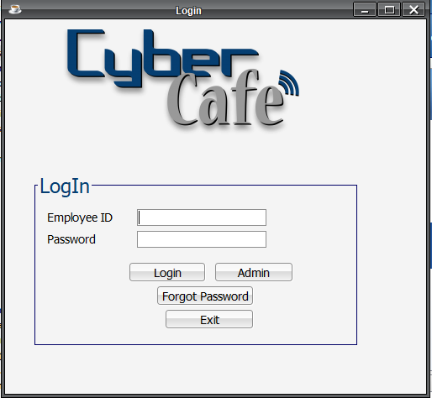
Fig 5.1 Login Page

In above figure, employee should enter id and password.

2.The Home Page

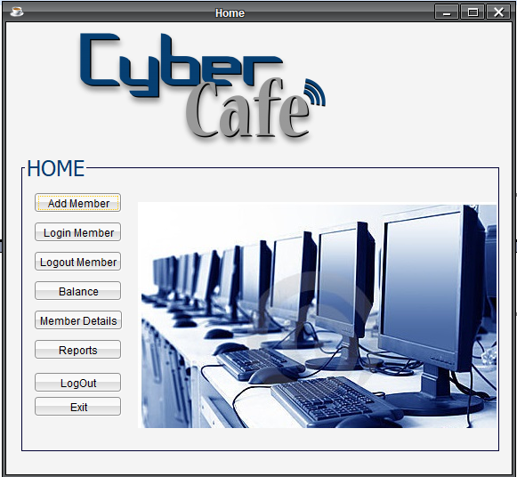
Fig5.2- Home Page

In above figure Employee access various functionalities like:
1.Add Member
2.Login Member
3.Logout Member
4.Balance Details
5.Member Details
6. See Reports

3.New Member page

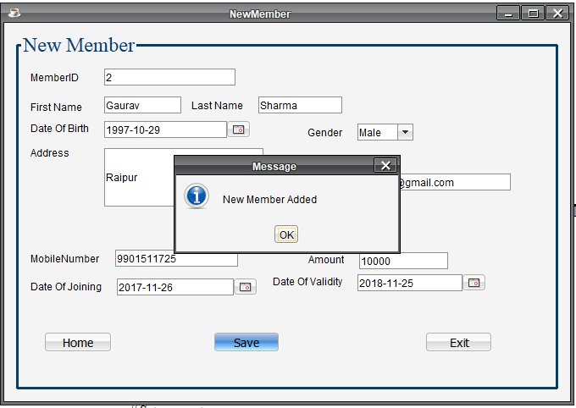
Fig 5.3-New Member Page
In above Figure ,Employee can add new member.

4.Login Member Page
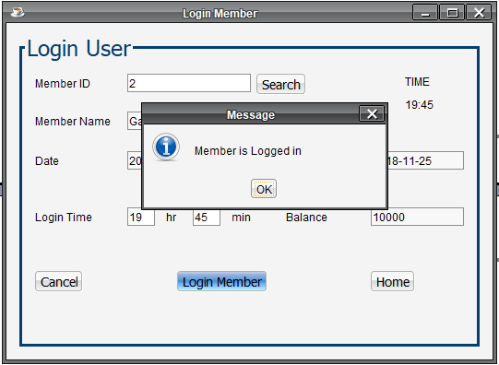
Fig5.4-Login Member Page
In Fig 5.4,Employee can enter the login details of member.

5.Balance Details

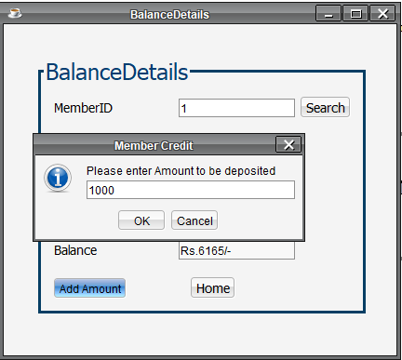
Fig 5.5-Balance Details Page
In above figure,Employee can see and credit balnce to member.

5.Logout Page (Bill generation Page)

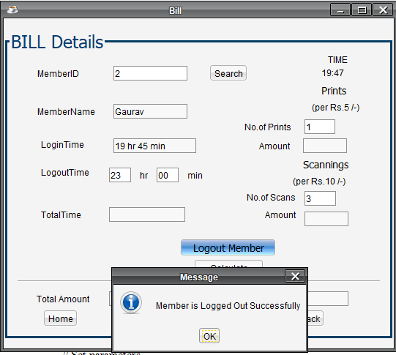
Fig 5.6-Bill Details Page
In above figure,Employee can logout member,and calculate bill.

7.Member Details Page

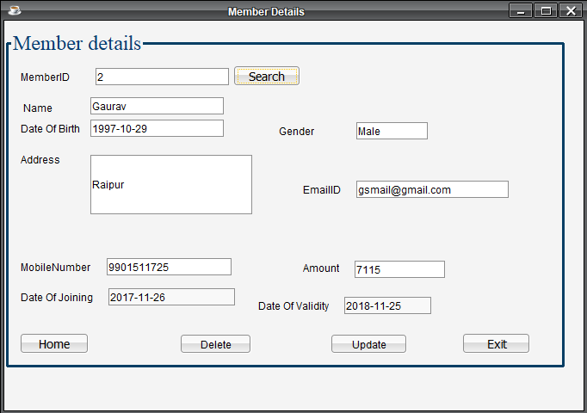
Fig 5.7-Member Details Page
In above figure,Employee user can see the member Details.

8.Records Page.
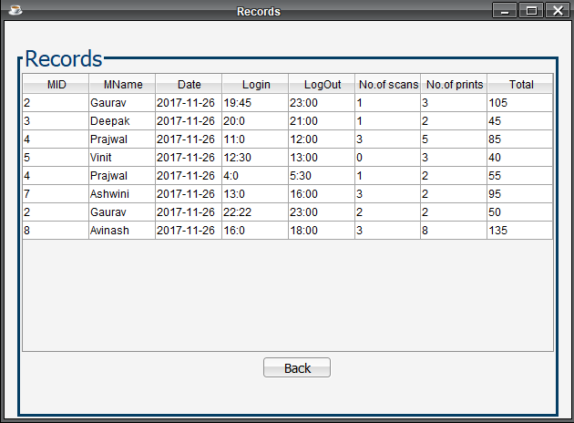
Fig .5.8-Records Page
In above Figure,Employee can see the records of members.

11.Trigger

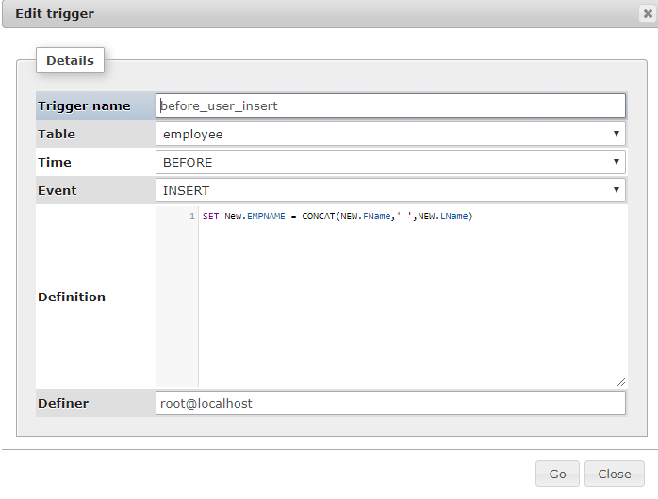
Fig 5.11-Trigger for adding empname
In above Figure, Trigger is used in Employee Table.
When values of Fname and Lname is Innserted in the Table
then trigger sets the EMPName by concatinating Fname and Lname

12.Stored Procedure
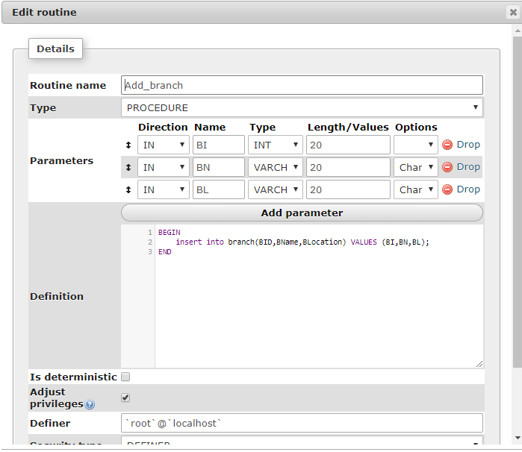
Fig 5.11-Stored procedure for adding branch details

In Fig 5.11 Stored Procedure is Used to insert into branch the Branch Table
by taking 4 IN parameteres .

Tables

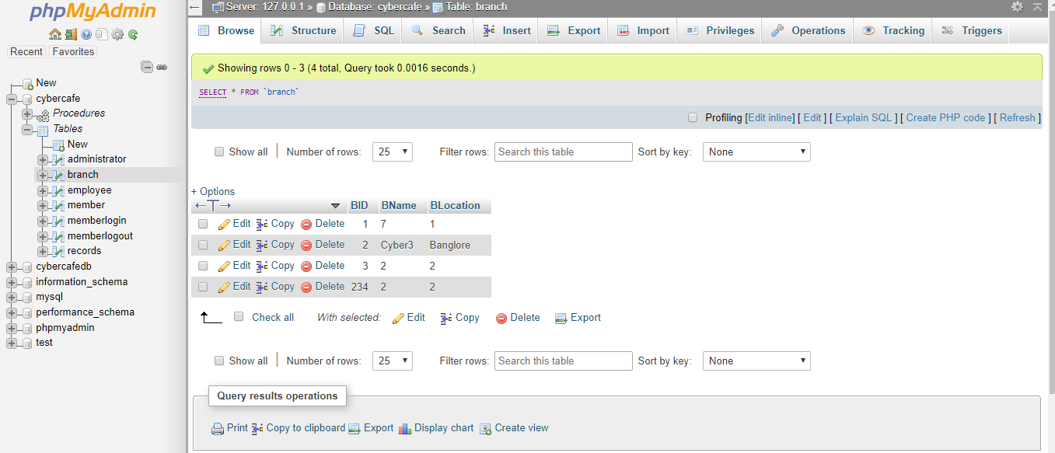
Fig .5.9-Branch Table
Above figure shows branch table which stores the branch_id as primary key,branch name and also branch location.

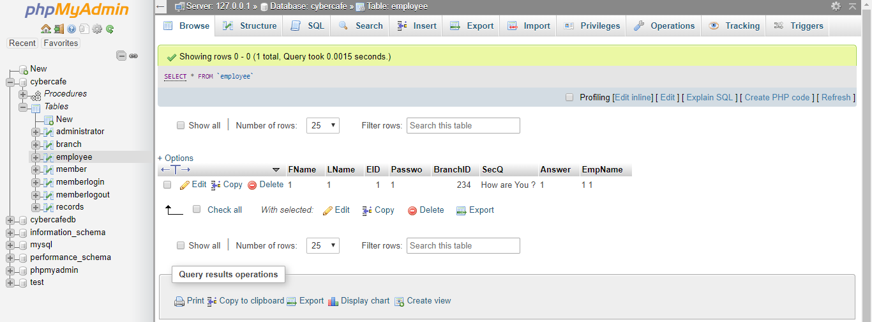
Fig .5.10-Employee Table
Above figure shows Employee table which has EID as primary key,Fname,Lname
Password,Security Question,Answer and Attribute EMPNAME is got by using Trigger.

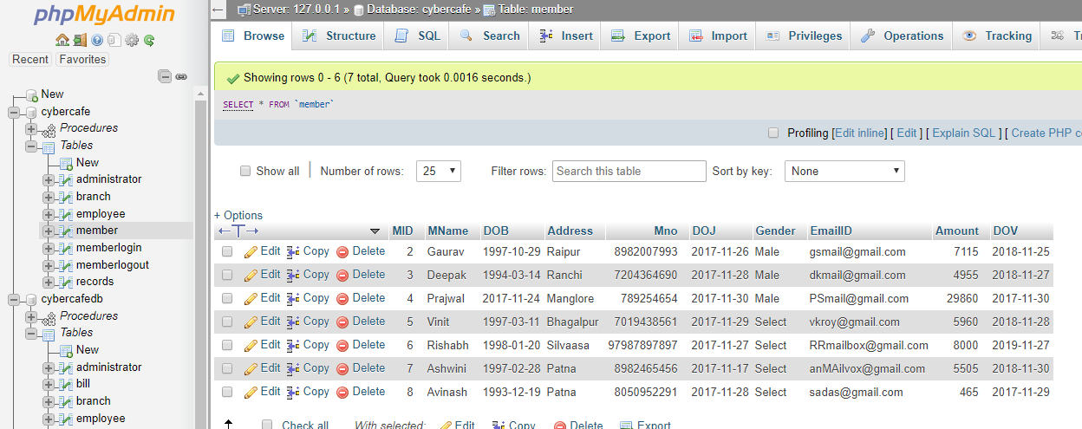
Fig .5.11-Member Table
Above figure shows Member Table which has,MID as Primary key,Mname,DOB,Address,DOJ,EmailID,Amount and DOV as its attributes.

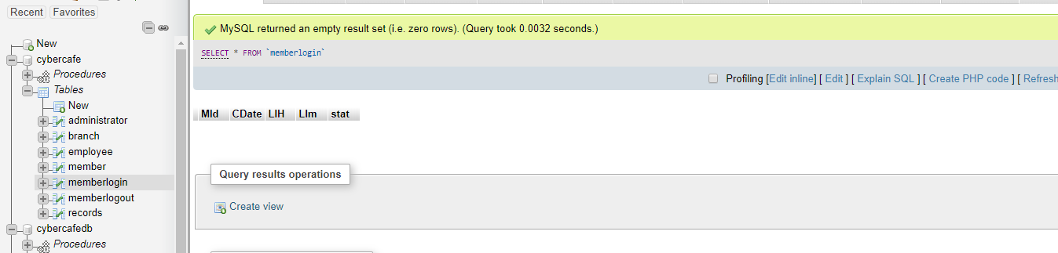
Fig .5.9-MemberLogin Table
Above figure shows MemberLogin table which has MID as its primary key,Cdate,LIH(denotes Login hour),LIM(Login Minute) as its attributes.
When a member is logged in its detail is stored here.

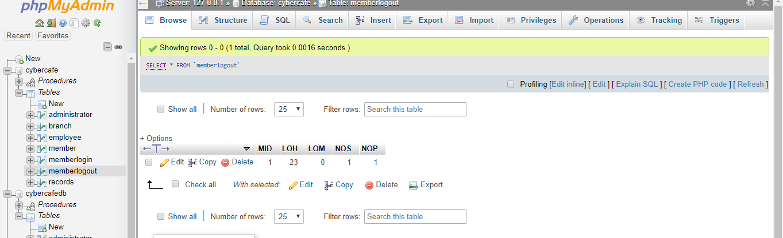
Fig .5.9-MemberLogOut Table
Above figure shows MemberLogin table which has MID as its primary keyLOH(denotes Logout hour),LOM(Logout Minute),NOP(number of prints) and NOS(no.of Scans) as its attributes. When a member is logged out its detail is stored here.

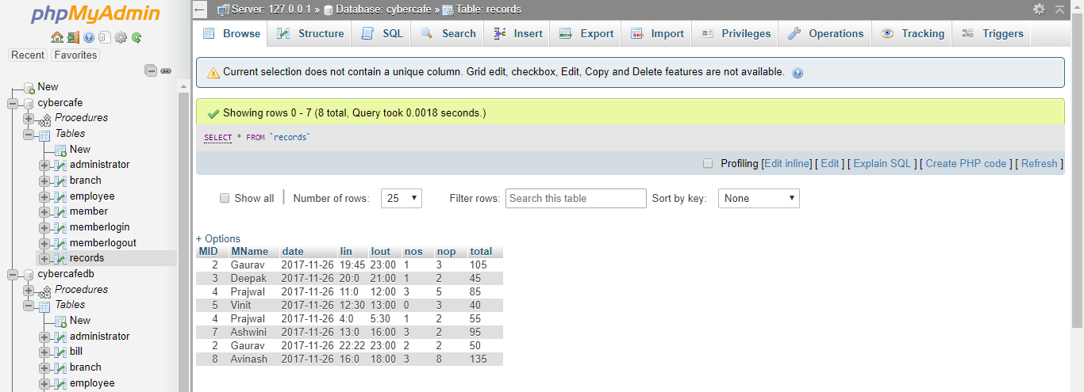

Fig .5.9-Bill Table
Above figure shows Bill Table which has MID,Mname,date,Lout,nos,nop,total as its attributes.This table is used basically to store the record of cyber cafe.

Chapter 7

Conclusion

This is a Cyber Cafe management Project that helps with managing customers and employees, controlling computers and printers, securing systems, accounting and billing. It simplifies and automates running your Internet Cafe business. Unlike many other competitive programs, Cyber cafe management system is robust, quick, secure and very intuitive and easy to use. It doesn't matter how big your Internet cafe is - Cyber cafe management system is designed to be a complete solution for Internet cafes and to make life easier for Internet cafe owners, operators and customers. The basic task of our software is to provide operators and customers with an accurate timing and billing information at any time. Cyber cafe management system
With the theoretical inclination of our syllabus, it becomes very essential to take the utmost advantage of any opportunity of gaining practical experience that comes along. The construction of this mini project “Cyber Café Mangement” was one of these opportunities. It gave us the requisite practical knowledge to supplement the already taught theoretical concepts, thus making us more competent.

References:
1· Java The Complete Reference by Herbert Schildt
2· J2EE-The Complete Reference by Jim Keogh
3· www.google.com.
4· www.wikipedia.com
5· www.w3schools.com
6·www.youtube.com

